# Hable easy manual

Updated 1st March 2024

This training guide will take you step by step through all functionalities of the Hable Easy. First, it explains how to get started and how to set up the Hable Easy correctly. Then it explains different modes of operation.

This guide is intended for new users, friends and family or technology trainers. You can reach out to [support@iamhable.com](mailto:support@iamhable.com) for queries or questions about smartphones or brand new hable Easy.

Here you can find an overview of the different chapters :

1. Setting up for the first time
2. Hable easy commands
3. Smartphone settings
4. Step by step lesson
5. Installing Hable Easy

With the help of this trainer guide, you will be able to use the controller quickly. This guide covers how to use the Hable with VoiceOver settings switched on. VoiceOver provides audio feedback while using the Hable One. It is also possible to use the Hable Easy without VoiceOver. We will cover that at the end of the chapter. First, we will explain how to hold, set up and use the Hable Easy.

Lastly, we would like to give a huge thanks to all the trainers who came up with the idea of Hable Easy and helped develop the product. Your efforts are being recognised in more than 10 countries around the world. Have fun with this starter guide!

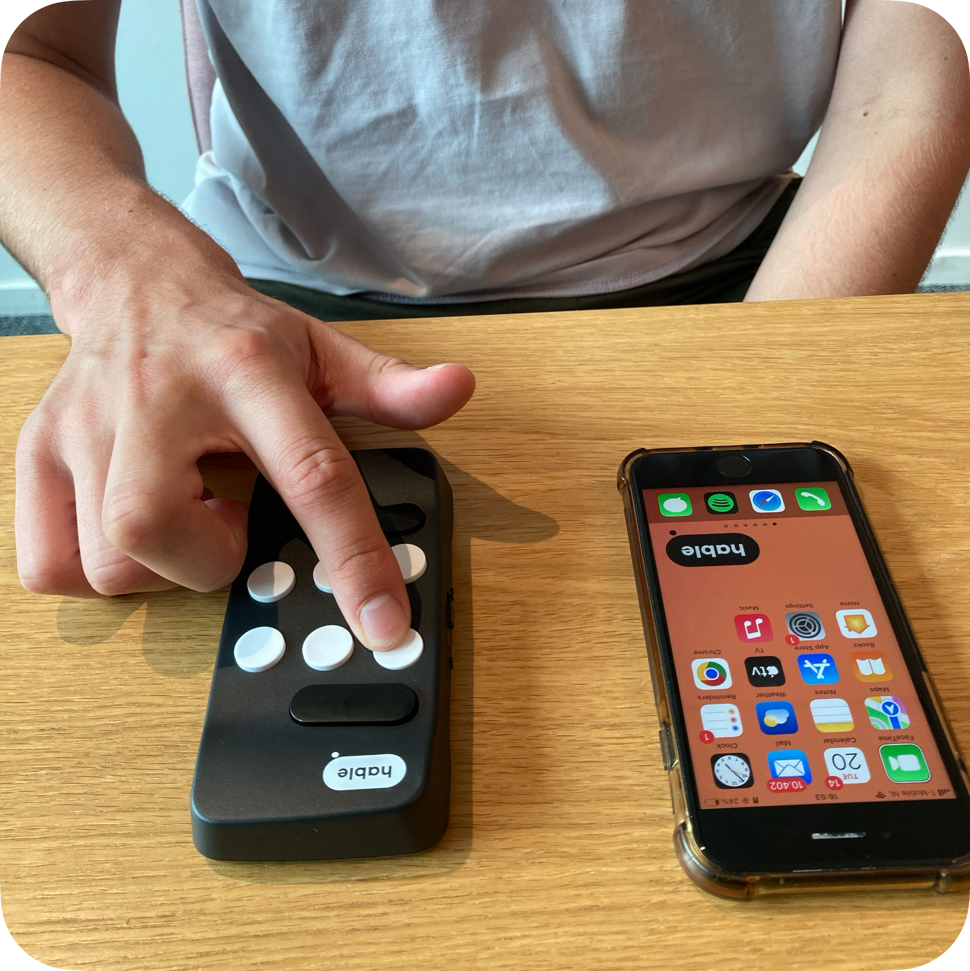

## 

## First time set-up

We made two videos explaining in full what the Hable Easy is. Subscribe to the YouTube channel for new content.

* [Introducing Hable Easy](https://www.youtube.com/watch?v=yamrxklO5IE&t=64s)
* [Hable Easy: Unleash Your Smartphone with Ease](https://www.youtube.com/watch?v=vCIIkHB3PSM&t=155s)

### Charging the Hable

When the Hable is out of battery, you can charge it with the cable that you received in the box. When it is fully empty it takes four to five hours to charge it completely. The charging port is on the bottom side of the Hable. When the charger is connected, there will be 3 short vibrations.

### Bluetooth

The Hable pairs using bluetooth. To pair the Hable with your smartphone, go to settings on your phone then turn on bluetooth. You can also use Siri to turn on bluetooth. Next step is to switch Hable on.

When you hold the device in the correct position, you turn the Hable on by sliding the slide switch all the way to the right. The Hable will vibrate twice when it is switched on. This indicates that the device is charged and ready to use. Next step is to pair the Hable with the phone.

Look for the name of the controller "Hable One", in the list of more devices. Once you have found the device name, double click to start pairing. If the controller is not visible, try turning the Hable One off and on again. If the pairing was successful, the Hable will vibrate to indicate that it is connected. The Hable is now ready to use.

### Installation

To install the update, open the Hable app > More updates > Test Version Easy Jan24 > then click on the ‘Install now’ button. Refer to our section on installation. Installing Hable Easy.

## 

## Holding Hable Easy

The Hable Easy has one flat side and one side with buttons. There is a power slider on the top side of the Hable Easy. When the power slider is facing the ceiling and the side with the buttons is pointing away from you, you can turn the Hable on by sliding the power slider to the right. On the bottom of the Hable, there is a charging port. On the bottom right of the Hable, there is a place to attach the lanyard, which is also included in the box. For Hable Easy, we designed 2 orientations.

Two hand mode or Hable mode. In this manner, the hable is held with two hands.

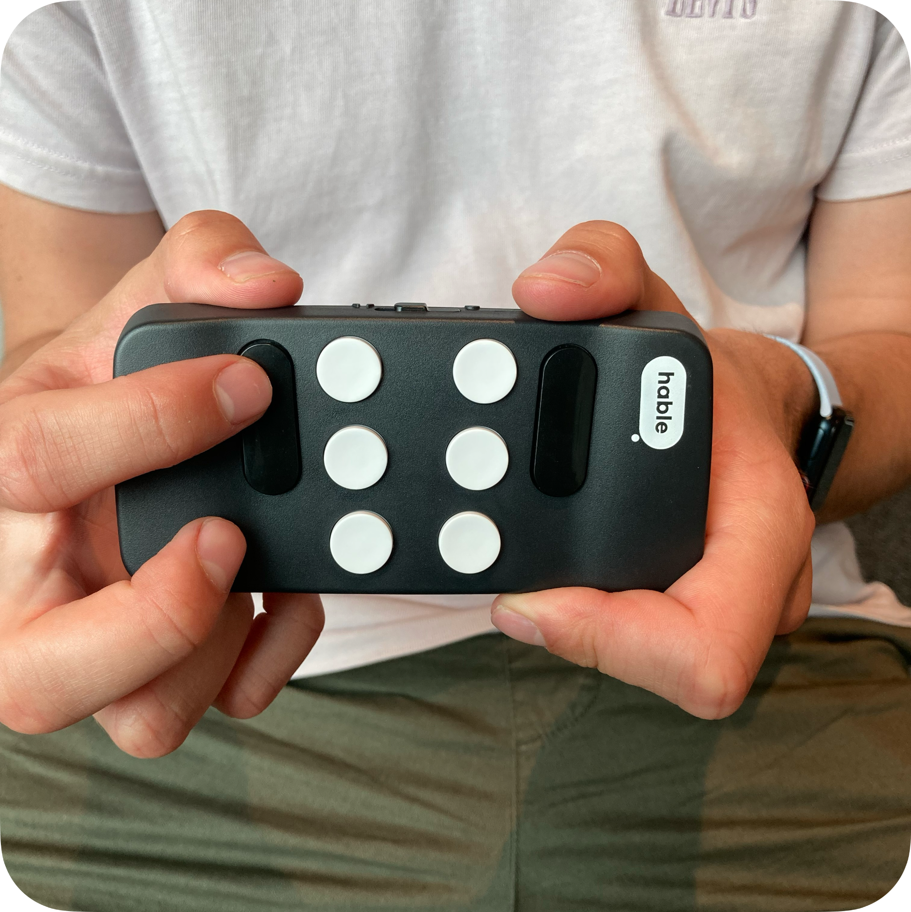

One hand mode or Remote mode. In this manner, the hable can be used with just 1 hand.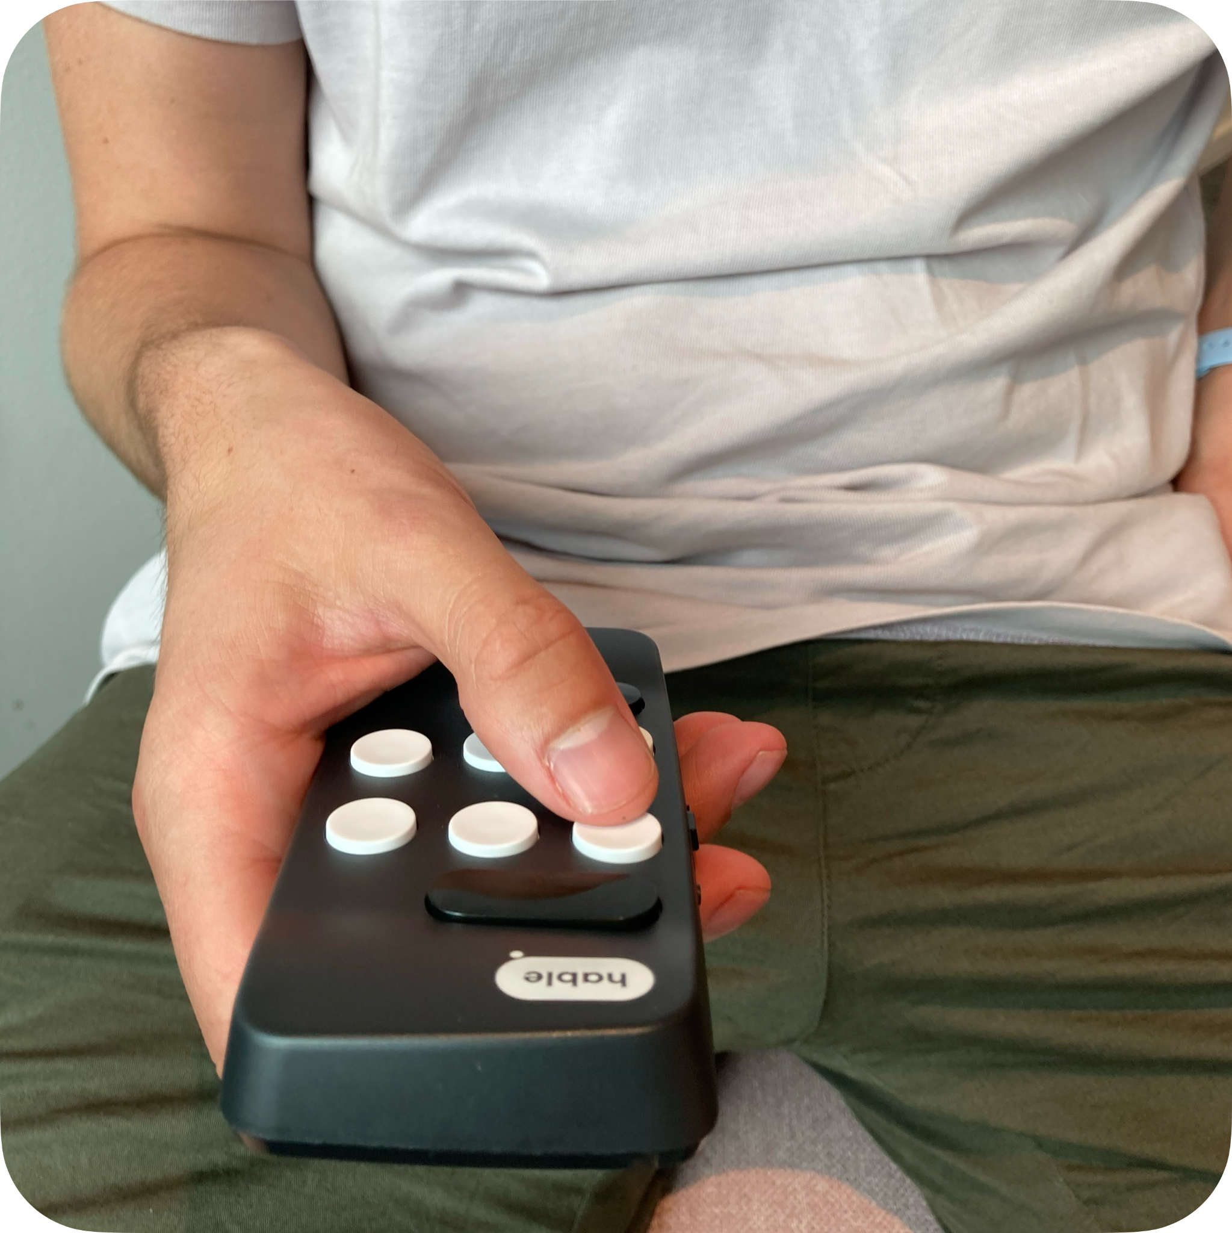

## 

# Hable Easy Commands

## Hable mode or two hand mode

Select item press Dot 1

Google now or Siri press Dot 2

Home press Dot 3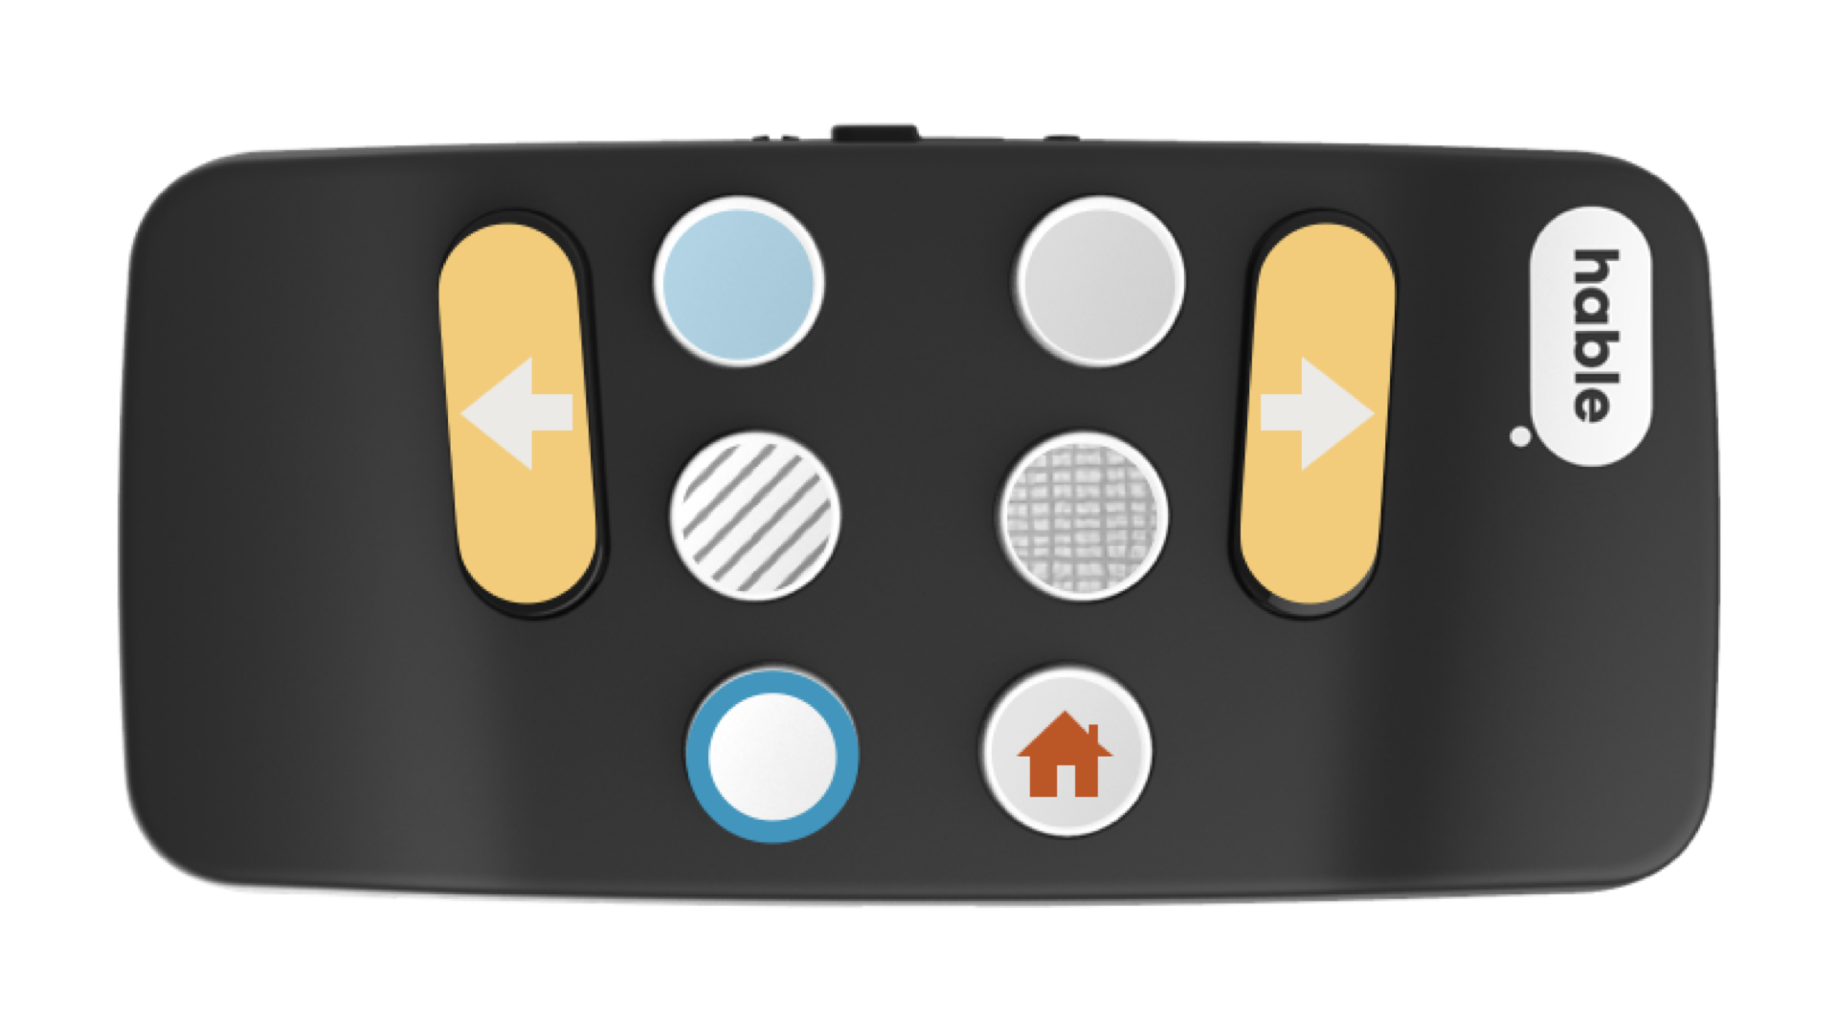

Play pause and magic tap press Dot 4

Dictation press Dot 5

Back press Dot 6

Previous item press Dot 7

Next item press Dot 8

## One hand modeHable easy in one hand mode orientation

Select item press Dot 2

Google now or Siri press Dot 6

Home press Dot 8

Play pause and magic tap press Dot 5

Dictation press Dot 4

Back press Dot 7

Previous item press Dot 3

Next item press Dot 1

# Menu Settings

## 

## Hable Easy in Two hand mode

Hold dots 1,2,3,4,5,6 + 2,3 for short press. Hold dots 1,2,3,4,5,6 + 1,3 for long press.

## Hable Easy One hand mode

Hold dots 1,2,3,4,5,6 + 5,6 for short press. Hold dots 1,2,3,4,5,6 + 4,6 for long press.

## Hable One mode

Hold dots 1,2,3,4,5,6 + 1,5 for english language. For other languages, please refer to Hable One manual.

# Smartphone Settings

## VoiceOver with Hable Easy

Make sure that VoiceOver is enabled on your phone. To do this go to your phone settings > Accessibility > VoiceOver > Turn on VoiceOver or use the accessibility shortcut to enable it. After enabling the settings, a cursor will appear. Also the phone will speak out loud the area selected by the cursor.

Demo video coming soon.

## Full Keyboard Access with Hable Easy

While using Full Keyboard Access settings, a cursor would appear. However the phone does not speak out loud. This is useful for those who would not like to hear the voice output but instead wish to use the phone with the screen.

To do this go to your phone settings > Accessibility > Keyboards > Full Keyboard Access.

First configure the Hable. To do this go to Full Keyboard Access > Commands. Select the commands to start configuring. Now click the button on the Hable to associate the command to the button.

To Restore defaults click the Restore Defaults button at the end of the list.

Demo video coming soon.

## Switch Control with Hable Easy

Using the Hable as switch control is for those who need switch access. To do this go to your phone settings > Accessibility > Switch Control.

First configure the Hable. To do this go to Switch Control > Switches > Add New Switch > External. Select the button on the Hable to start the configuration process. Follow the steps on the phone.

Demo video coming soon.

# 

# Step by Step Lessons

## Picking up and Hanging phone calls

To pick up an incoming phone call use the play pause and magic tap button. To pick-up a phone call press dot 4. Use the same dot to hang up.

Play pause and magic tap are also useful to play or pause music players and audio books.

## Making a call via Siri

* First, press button 2. Once you press this button, Siri will listen.
* You can now say something like 'call John'.
* If the person you want to call has multiple numbers, Siri will ask which number you want. For example, 'John, home or mobile?'.
* Now say which number you want.
* Once you've done this, Siri confirms your choice. This sounds like 'I'm calling John home'. If you said mobile, Siri says 'I'm calling John mobile'. Then the call is automatically started.
* When you are finished calling and want to end the conversation, press button 4. Pressing this button ends the call.

## Making a call through the contacts app.

* If you end up in a place not covered by this explanation or if you get lost and want to start over, you need to go back to the home screen. You do this by pressing button 3.
* Press button 8 to scroll through your apps.
* Keep pressing button 8 until you hear 'contacts'.
* Press button 1 to open the app. Have you scrolled too far? No problem. If you press button 7 on the bottom left, you will go back one item.
* You can use button 8 again to scroll through your contacts. Keep pressing until you hear the name of the contact you want to call.
* Now press button 8 again to scroll through the different options.
* If you have multiple numbers saved, these options will be listed. They will be read as 'mobile, call.'.
* When you find the correct number, press button 1. The call will now be initiated.

## 

## 

# How to Install Hable Easy

1. Download the Hable app from the play store (iphone or ipad). You can use this link to open the app on your iPhone or iPad. Link: <https://apps.apple.com/nl/app/hable/id1626484835>
2. To search for the Hable app on the app store. Go to app store > Search, and then search for Hable. The Hable app might be third or forth from the top.
3. Click on the Download button or Get button to install the app. Open the app. You will get the following alerts as soon as you open your app:
   1. Alert 1: “Hable” Would like to use bluetooth. Be sure to press “OK” .
   2. Alert 2: “Hable” would like to send your notifications. It is not mandatory to allow this.
   3. Alert 3: “Hable” would like to use bluetooth for new connections. Be sure to press “OK”.
4. Make sure your Hable One is already connected to your iPhone or iPad via bluetooth.
5. **To install the update, open the Hable app > More updates > Test Version 2024 > then click on the ‘Install now’ button.** Attention: Please do not switch off the Hable One or Hable app during the updating process.
6. The process takes 60 seconds. When the Hable vibrates, the updating process is complete. To note: the app itself will not display a message if the update was successful. If you don’t encounter an error, then there’s nothing to worry about, you have the latest update installed to your Hable!
7. Now you can use the Menu settings to switch to Hable Easy mode.

Please feel free to reach out if you have any further questions or if there's anything else we can assist you with. Additionally, if the installation fails again, it would be incredibly helpful if you or your family could send us a picture of the screenshot of any error messages you encounter. This will enable us to better understand the problem and provide you with the most accurate solution.